**Optimized SinCos Algorithm**

1. **Background:**

The following diagram is an overview of the operations that are performed during digital motor angle initialization to compute their correction tables.

Generate Reconstructed Waveform Pseudo Code:

*for n = 0 to 128* // size of correction table

$ReconstructedWaveform[n]≅\sum_{i=1}^{12}{Acoeff\left[i\right]*\cos\left(\frac{n*2pi*i}{127}\right)+}Bcoeff\left[i\right]*\sin\left(\frac{n*2pi*i}{127}\right)$

As shown in the pseudo code there is several calls to the sine and cosine function (128 * 12). Furthermore, the algorithm requires both the sine and cosine of the same angle. During benchmarking activities the following algorithm was developed and shown to have significant time improvements (~= 5.5 mSec vs ~= 2.4 mSec) over the standard sine and cosine library functions.

1. **Sine and Cosine as Taylor Series:**
$$Sin\left(x\right)=x-\frac{x^{3}}{3!}+\frac{x^{5}}{5!}-\frac{x^{7}}{7!}…$$

$$Cos\left(x\right)=1-\frac{x^{2}}{2!}+\frac{x^{4}}{4!}-\frac{x^{5}}{5!}…$$

2. **Range Reduction:**

Although the Taylor Series for sine and cosine are exact it technically takes an infinite number of terms. The purpose of limiting the value of x into the Taylor Series is so that it doesn’t take many terms before the factorial in the denominator dwarfs the numerator. To limit the input range of x the following identity is used:

$$Sin\left(A+B\right)=Sin\left(A\right)Cos\left(B\right)+Sin\left(B\right)Cos(A)$$

For reasons that will be discussed later B will be declared as 22.5n, where n is an integer between 0 and 15. Using this technique the largest x input into the Taylor Series will be +/- 11.25 Degrees (0.1963 Radians).

Now that the maximum input value of x has been established it is possible to determine the number of terms in the Taylor Series that are required to achieve acceptable levels of accuracy.

| **# of Terms** | **Sin(x)** | **Sin(x) Max Error** | **Cos(x)** | **Cos(x) Max Error** |
| --- | --- | --- | --- | --- |
| **1** | $$Sin\left(x\right)=x$$ | **0.001259** | $$Cos\left(x\right)=1$$ | **0.0192** |
| **2** | $$Sin\left(x\right)=x-\frac{x^{3}}{3!}$$ | **2.4297E-6** | $$Cos\left(x\right)=1-\frac{x^{2}}{2!}$$ | **6.18515E-5** |
| **3** | $$Sin\left(x\right)=x-\frac{x^{3}}{3!}+\frac{x^{5}}{5!}$$ | **2.2312E-9** | $$Cos\left(x\right)=1-\frac{x^{2}}{2!}+\frac{x^{4}}{4!}$$ | **7.953E-8** |

As the table above shows an acceptable level of accuracy can be achieved with only 2 terms in the sine and cosine Taylor Series once the input has been range limited to +/- 11.25 degrees.

1. **Algorithm:**

**Calculate n & B:**

As shown before, n is the largest integer that satisfies: 22.5n < x. This can be performed using integer math where:

$$n=floor\left(\frac{x*8}{π}\right):where\frac{8}{π}Radians=22.5 Degrees$$

The above equation will leave a remainder that ranges from 0 to 22.5 degrees. By adding in a 0.5 term the result will round up leaving a remainder with the desired range of +/- 11.25 Degrees. Therefore n is calculated as:

$$n=floor\left(\frac{x*8}{π}+0.5\right)$$

The B term is a simple multiple of n:

$$B=\frac{π}{8}*n$$

**Determine A:**

The A term is the effective remainder of the input angle *x* minus the B term.

$$A=x-B$$

**Compute Sin(A) & Cos(A):**

Once input x has been range limited into A the term limited Taylor Series of sine and cosine can be computed:

$$Sin\left(A\right)=A-\frac{A^{3}}{3!}$$

$$Cos\left(A\right)=1-\frac{A^{2}}{2!}$$

**Compute Sin(x):**

Now that Sin(A) & Cos(A) have been determined they can be combined with Sin(B) & Cos(B) to determine Sin(x). The B term is a function of n, which was earlier stated to be a multiple of 22.5 degrees of which there are 16 per revolution. Input x is has no theoretical bound but determining Sin(B) & Cos(B) can be simplified by normalizing n into a single revolution. With n having 16 steps per revolution the normalization is a simple bit mask.

$$n_{nrml}=n \& 0xF$$

With normalized n determined it can be used as an index into a switch case statement to determine Sin(x)

Switch (n_nrml)

Case 0:

Sinx = Sin(A)Cos(22.5 * 0) + Sin(22.5 * 0)Cos(A)

Case 1:

Sinx = Sin(A)Cos(22.5 * 1) + Sin(22.5 * 1)Cos(A)

Case 2:

Sinx = Sin(A)Cos(22.5 * 2) + Sin(22.5 * 2)Cos(A)

Case 3:

Sinx = Sin(A)Cos(22.5 * 3) + Sin(22.5 * 3)Cos(A)

Case 4:

Sinx = Sin(A)Cos(22.5 * 4) + Sin(22.5 * 4)Cos(A)

Case 5:

Sinx = Sin(A)Cos(22.5 * 5) + Sin(22.5 * 5)Cos(A)

Case 6:

Sinx = Sin(A)Cos(22.5 * 6) + Sin(22.5 * 6)Cos(A)

Case 7:

Sinx = Sin(A)Cos(22.5 * 7) + Sin(22.5 * 7)Cos(A)

Case 8:

Sinx = Sin(A)Cos(22.5 * 8) + Sin(22.5 * 8)Cos(A)

Case 9:

Sinx = Sin(A)Cos(22.5 * 9) + Sin(22.5 * 9)Cos(A)

Case 10:

Sinx = Sin(A)Cos(22.5 * 10) + Sin(22.5 * 10)Cos(A)

Case 11:

Sinx = Sin(A)Cos(22.5 * 11) + Sin(22.5 * 11)Cos(A)

Case 12:

Sinx = Sin(A)Cos(22.5 * 12) + Sin(22.5 * 12)Cos(A)

Case 13:

Sinx = Sin(A)Cos(22.5 * 13) + Sin(22.5 * 13)Cos(A)

Case 14:

Sinx = Sin(A)Cos(22.5 * 14) + Sin(22.5 * 14)Cos(A)

Case 15:

Sinx = Sin(A)Cos(22.5 * 15) + Sin(22.5 * 15)Cos(A)

The Sin(B) & Cos(B) terms above can be simplified due to their symmetrical nature into 3 predefined constants:

$$Sin\left(22.5\right)=Cos\left(67.5\right)=0.38263$$

$$Sin\left(45.0\right)=Cos\left(45.0\right)=0.70710$$

$$Sin\left(67.5\right)=Cos\left(22.5\right)=0.92387$$

**Cos(x) for Free (almost):**

The previous calculation computed Sin(x) as a function of Sin(A), Cos(A), Sin(B) & Cos(B). As it turns out cosine has a similar trig identity that uses the exact same terms.

$$Cos\left(A+B\right)=Cos\left(A\right)Cos\left(B\right)-Sin\left(A\right)Sin(B)$$

The switch case can be modified to simultaneously be used to return the sine and cosine of the same angle at the same time:

Switch (n_nrml)

Case 0:

Sinx = Sin(A)Cos(22.5 * 0) + Sin(22.5 * 0)Cos(A)

Cosx = Cos(A)Cos(22.5 * 0) + Sin(A) Sin(22.5 * 0)

Case 1:

Sinx = Sin(A)Cos(22.5 * 1) + Sin(22.5 * 1)Cos(A)

Cosx = Cos(A)Cos(22.5 * 1) + Sin(A) Sin(22.5 * 1)

Case 2:

Sinx = Sin(A)Cos(22.5 * 2) + Sin(22.5 * 2)Cos(A)

Cosx = Cos(A)Cos(22.5 * 2) + Sin(A) Sin(22.5 * 2)

Case 3:

Sinx = Sin(A)Cos(22.5 * 3) + Sin(22.5 * 3)Cos(A)

Cosx = Cos(A)Cos(22.5 * 3) + Sin(A) Sin(22.5 * 3)

Case 4:

Sinx = Sin(A)Cos(22.5 * 4) + Sin(22.5 * 4)Cos(A)

Cosx = Cos(A)Cos(22.5 * 4) + Sin(A) Sin(22.5 * 4)

Case 5:

Sinx = Sin(A)Cos(22.5 * 5) + Sin(22.5 * 5)Cos(A)

Cosx = Cos(A)Cos(22.5 * 5) + Sin(A) Sin(22.5 * 5)

Case 6:

Sinx = Sin(A)Cos(22.5 * 6) + Sin(22.5 * 6)Cos(A)

Cosx = Cos(A)Cos(22.5 * 6) + Sin(A) Sin(22.5 * 6)

Case 7:

Sinx = Sin(A)Cos(22.5 * 7) + Sin(22.5 * 7)Cos(A)

Cosx = Cos(A)Cos(22.5 * 7) + Sin(A) Sin(22.5 * 7)

Case 8:

Sinx = Sin(A)Cos(22.5 * 8) + Sin(22.5 * 8)Cos(A)

Cosx = Cos(A)Cos(22.5 * 8) + Sin(A) Sin(22.5 * 8)

Case 9:

Sinx = Sin(A)Cos(22.5 * 9) + Sin(22.5 * 9)Cos(A)

Cosx = Cos(A)Cos(22.5 * 9) + Sin(A) Sin(22.5 * 9)

Case 10:

Sinx = Sin(A)Cos(22.5 * 10) + Sin(22.5 * 10)Cos(A)

Cosx = Cos(A)Cos(22.5 * 10) + Sin(A) Sin(22.5 *10)

Case 11:

Sinx = Sin(A)Cos(22.5 * 11) + Sin(22.5 * 11)Cos(A)

Cosx = Cos(A)Cos(22.5 * 11) + Sin(A) Sin(22.5 * 11)

Case 12:

Sinx = Sin(A)Cos(22.5 * 12) + Sin(22.5 * 12)Cos(A)

Cosx = Cos(A)Cos(22.5 * 12) + Sin(A) Sin(22.5 * 12)

Case 13:

Sinx = Sin(A)Cos(22.5 * 13) + Sin(22.5 * 13)Cos(A)

Cosx = Cos(A)Cos(22.5 * 13) + Sin(A) Sin(22.5 * 13)

Case 14:

Sinx = Sin(A)Cos(22.5 * 14) + Sin(22.5 * 14)Cos(A)

Cosx = Cos(A)Cos(22.5 * 14) + Sin(A) Sin(22.5 * 14)

Case 15:

Sinx = Sin(A)Cos(22.5 * 15) + Sin(22.5 * 15)Cos(A)

Cosx = Cos(A)Cos(22.5 * 15) + Sin(A) Sin(22.5 * 15)

1. **Performance:**

The following graph shows the output and error of the algorithm. The maximum errors for sine and cosine are:

SinErrorMax = 6.1799e-05

CosErrorMax = 6.1618e-05

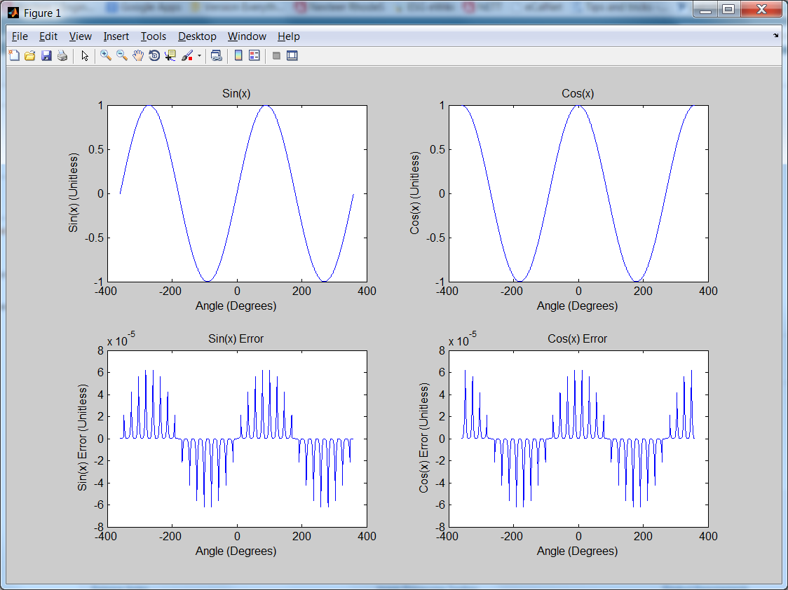

1. **Matlab Code:**

%% Optimized SinCos Algorithm

ArraySize = uint16(100000);

PiOverEight = pi/8;

EightOverPi = 8/pi;

sin225 = sin(22.5/180*pi);

sin450 = sin(45.0/180*pi);

sin675 = sin(67.5/180*pi);

x = linspace(-2*pi, 2*pi,ArraySize)';

SinX = zeros(ArraySize,1);

CosX = zeros(ArraySize,1);

n = int16(floor(x * EightOverPi + 0.5));

A = (x - double(n) * PiOverEight);

SinA = A - (A.^3)/6;%+(A.^5)/120;

CosA = 1 - (A.^2)/2;%+(A.^4)/24;

n_nrml = bitand(n,15);

for i = 1:ArraySize

switch n_nrml(i)

case 0

SinX(i) = SinA(i);

CosX(i) = CosA(i);

case 1

SinX(i) = sin675 * SinA(i) + sin225 * CosA(i);

CosX(i) = -sin225 * SinA(i) + sin675 * CosA(i);

case 2

SinX(i) = sin450 * SinA(i) + sin450 * CosA(i);

CosX(i) = -sin450 * SinA(i) + sin450 * CosA(i);

case 3

SinX(i) = sin225 * SinA(i) + sin675 * CosA(i);

CosX(i) = -sin675 * SinA(i) + sin225 * CosA(i);

case 4

SinX(i) = CosA(i);

CosX(i) = -SinA(i);

case 5

SinX(i) = -sin225 * SinA(i) + sin675 * CosA(i);

CosX(i) = -sin675 * SinA(i) + -sin225 * CosA(i);

case 6

SinX(i) = -sin450 * SinA(i) + sin450 * CosA(i);

CosX(i) = -sin450 * SinA(i) + -sin450 * CosA(i);

case 7

SinX(i) = -sin675 * SinA(i) + sin225 * CosA(i);

CosX(i) = -sin225 * SinA(i) + -sin675 * CosA(i);

case 8

SinX(i) = -SinA(i);

CosX(i) = -CosA(i);

case 9

SinX(i) = -sin675 * SinA(i) + -sin225 * CosA(i);

CosX(i) = sin225 * SinA(i) + -sin675 * CosA(i);

case 10

SinX(i) = -sin450 * SinA(i) + -sin450 * CosA(i);

CosX(i) = sin450 * SinA(i) + -sin450 * CosA(i);

case 11

SinX(i) = -sin225 * SinA(i) + -sin675 * CosA(i);

CosX(i) = sin675 * SinA(i) + -sin225 * CosA(i);

case 12

SinX(i) = -CosA(i);

CosX(i) = SinA(i);

case 13

SinX(i) = sin225 * SinA(i) + -sin675 * CosA(i);

CosX(i) = sin675 * SinA(i) + sin225 * CosA(i);

case 14

SinX(i) = sin450 * SinA(i) + -sin450 * CosA(i);

CosX(i) = sin450 * SinA(i) + sin450 * CosA(i);

case 15

SinX(i) = sin675 * SinA(i) + -sin225 * CosA(i);

CosX(i) = sin225 * SinA(i) + sin675 * CosA(i);

end

end

SinError = sin(x) - SinX;

CosError = cos(x) - CosX;

SinErrorMax = max(SinError)

CosErrorMax = max(CosError)

subplot(2,2,1) % first subplot

plot(x*180/pi,SinX)

title('Sin(x)')

xlabel('Angle (Degrees)')

ylabel('Sin(x) (Unitless)')

subplot(2,2,2) % second subplot

plot(x*180/pi,CosX)

title('Cos(x)')

xlabel('Angle (Degrees)')

ylabel('Cos(x) (Unitless)')

subplot(2,2,3) % third subplot

plot(x*180/pi,SinError)

title('Sin(x) Error')

xlabel('Angle (Degrees)')

ylabel('Sin(x) Error (Unitless)')

subplot(2,2,4) % fourth subplot

plot(x*180/pi,CosError)

title('Cos(x) Error')

xlabel('Angle (Degrees)')

ylabel('Cos(x) Error (Unitless)')